YEAR 12 PHYSICS
TOPIC TEST 2, 2020
TASK 3
GRAVITY, SATELLITES AND STATIC EQUILIBRIUM

SOLUTIONS

1. (4 marks)

Satellites orbiting freely around the Earth are sometimes placed in equatorial orbits (diagram A) and sometimes in polar orbits (diagram B). Explain why the orbits in diagram C are physically impossible for satellites.

The orbit’s centre should coincide with the centre of the Earth (1 mark)

since the centripetal force to keep satellites in orbit (1 mark)

has to act towards the centre of the Earth. (1 mark)

The centre of orbits in diagram C do not satisfy this, (1 mark)
hence they are physically impossible.

2. (4 marks)

A tradesperson leans a ladder against the gutter of a house and is careful to make the angle between the ground and the ladder as large as practical.

- Use arrows to show all the forces on the ladder in the diagram below. (2 marks)

ROOF
LADDER
F_{ground}
mg

b) If the angle ɵ is increased, how does it affect the reaction from the ground? Explain your answer. (2 marks)

When angle ɵ increases, the horizontal force from the wall decreases (1 mark)

which decreases the reaction from the ground. (1 mark)

Optional reasoning

F_{wall}. l sin ɵ = F_{ladder} $\frac{l}{2}$ cos ɵ

F_{wall} = $\frac{F_{ladder}}{2}$ $\frac{cos ɵ }{sin ɵ}$

As ɵ increases F_{wall} decreases
F_{ground} = $√F_{ladder}^{2}{+F}_{wall}^{2}$

Therefore F_{ground} decreases

3. Suppose that in the future, as a way to combat global warming, the Earth was moved to a new orbit with a mean radius 5.00% larger than the current one. How many more days would the Earth take to orbit the Sun in this new orbit? (4 marks)

Let r be the radius of the orbit from the Sun to Earth, 1 Earth day = 365.25 days

T² = $\frac{4π^{2}(1.05{r)}^{3}}{GM}$ (1 mark)

= 1.158 $\frac{4π^{2}r^{3}}{GM}$ (1 mark)

= 1.158 (365.25)² (1 mark)

T = $\sqrt{1.158}$ x 365.25 =392.98 days

392.98 – 365.25 = 27.7 more days (1 mark)

4. (5 marks)

The diagram below represents the human shoulder joint and the attached arm(courtesy Mr Taylor). The shoulder joint has the deltoid muscle connected to the humerus, a bone in the upper arm around 15 cm from the shoulder joint. The arm has a mass of 3.50 kg.
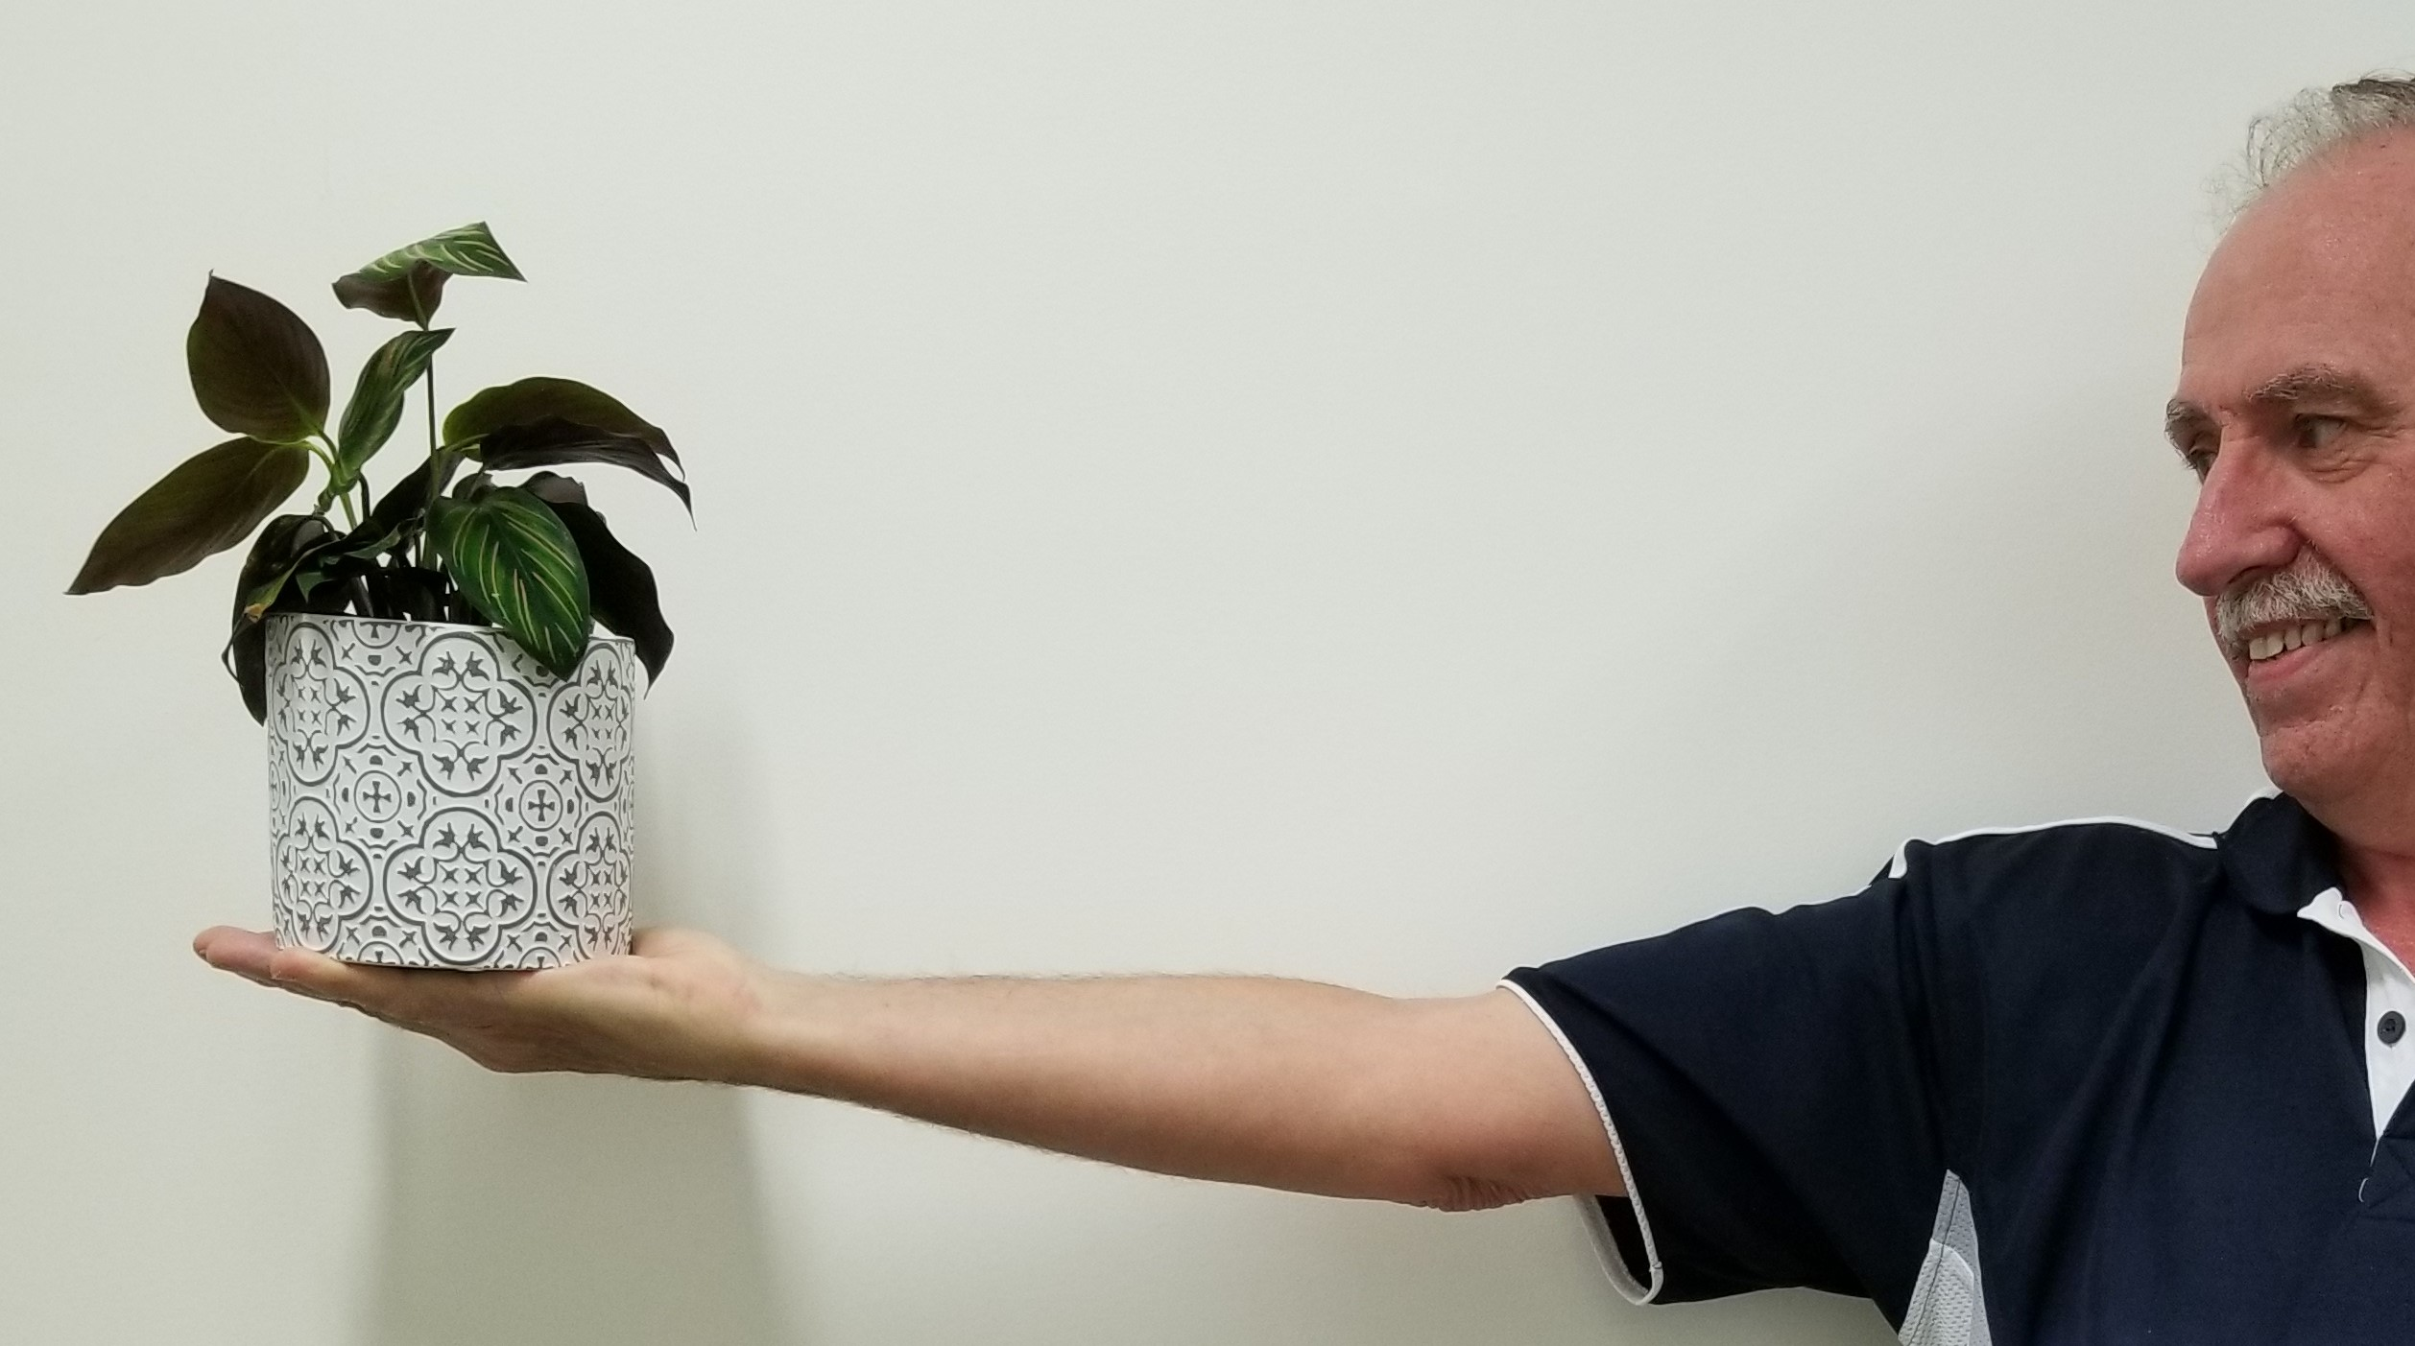

Deltoid muscle

15^{O}

0.64m 0.19m 0.15m

LOAD ARM WEIGHT

a) If the arm and shoulder are in a state of static equilibrium, what conditions must be met? (2 marks)

∑F_{up} = ∑F_{down}, ∑F_{left} = ∑F_{right} OR The arm and shoulder are in translational
equilibrium (1 mark) OR SUM OF ALL FORCES = 0

∑Ƭ_{clockwise} = ∑Ƭ_{anti-clockwise} OR The arm and shoulder is in rotational equilibrium (1 mark)

b) Calculate the tension in the deltoid muscle when a 2.00 kg flower pot (the load) is held in the hand with the arm outstretched. (3 marks)

Taking the pivot as the shoulder joint

∑Ƭ_{clockwise} = ∑Ƭ_{anti-clockwise}

(3.50 x 9.8 x 0.34) + (2.00 x 9.8 x 0.98) = F_{tension} sin 15 º x 0.15 (2 marks)

F_{tension} = 795 N (1 mark)
5. (14 marks)
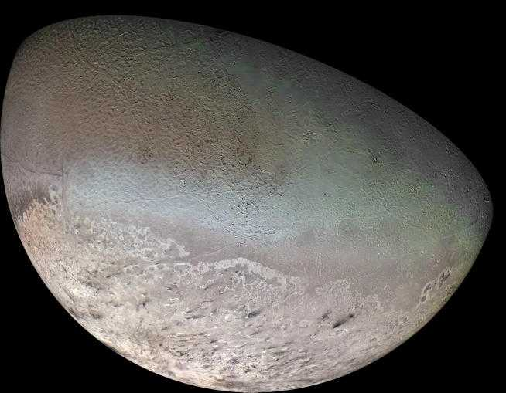

The planet Neptune has eight moons, one of which is called Triton. Inside a spacecraft at rest on Triton’s surface is a 10.0 kg mass hanging from a spring balance. The spring balance measures force in Newtons.

Mass of Triton = 2.14 x 10²³ kg
Radius of Triton = 1.3(5 x 10⁶ m
Mass of spacecraft = 2.00 x 10³ kg
Radius of Triton’s orbit around Neptune = 3.53 x 10⁸ m

- What is the reading on the spring balance in Newtons? (3 marks)
(1 mark)

= (6.67 x 10⁻¹¹ x 2.14 x 10²³) =7.83 m s⁻² or N kg⁻¹ (1 mark)
(1.35 x 10⁶)²
F_{weight} = mg = 10 x 7.83 = 78.3 N (1 mark)

Mass of Triton = 2.14 x 10²³ kg
Radius of Triton = 1.35 x 10⁶ m
Mass of spacecraft = 2.00 x 10³ kg
Radius of Triton’s orbit around Neptune = 3.53 x 10⁸ m

The spacecraft takes off and is now in circular motion around Triton, at an altitude of 2.70 x 10⁶ m.

b) What is the gravitational field strength at this altitude due to Triton? (3 marks)
= (6.67 x 10⁻¹¹ x 2.14 x 10²³) = (2 marks)
[(6.75 x 10⁵) + (2.70 x 10⁶)]²

= 0.870 m s⁻² or N kg⁻¹ (1 mark)

c) Another moon of Neptune is Nereid, which orbits at a distance of 5.50 x 10⁹ m from Neptune’s centre. Nereid takes 360 days to orbit Neptune. Determine the mass of Neptune. (4 marks)
(1 mark)

(360 x 24 x 3600)² = $\frac{4π^{2}{(5.5 x {10}^{9} )}^{3}}{(6.67 x {10}^{-11})M}$ (2 marks)
M = 1.02 x 10²⁶ kg (1 mark)

d) When Neptune is in position Z (not drawn to scale), what is the net gravitational force that the spacecraft experiences? (5 marks)
s is for spacecraft

Net F =( $\frac{GM_{Neptune}m_{s}}{r_{Neptune to s}^{2}}$) – ($\frac{GM_{Triton}m_{s}}{r_{Triton to s}^{2}}$) (1 mark)

=[$(\frac{{6.67 x 10}^{-11} x {2.14 x 10}^{23 }x {2.00 x 10}^{3}}{(4.05 x {10}^{6} ){}^{2}}$) - $\frac{{(6.67 x 10}^{-11} x {1.02 x 10}^{26 } x {2.00 x 10}^{3 )}}{(3.49 x {10}^{8}){}^{2}}$] (2 marks)

= 1.63 x 10³ N towards Triton (2 marks)

6. (13 marks)
A metal structure, ABCD, is used as part of a crane to lift a heavy load. It is hinged at the wall at A and is supported by a steel cable attached to a point X, 6.45 m above the hinge. The angle between the cable and the wall is 37º. The weight of ABCD is 950 N. A load of 154 kg is being lifted at C. Other dimensions are: AD = 2.50 m, DC = 2.50 m, BD = 1.50 m.
- Calculate the tension the cable. (4 marks)
Taking A as the pivot,
∑Ƭ_{clockwise} = ∑Ƭ_{anti-clockwise} Identify CW and ACW torque accurately (1 mark)
(2.50 x 950) + (5.00 x 154 x 9.8) = 6.45 x F_{tension} x sin 37º (2 marks)
F_{tension} = 2.56 x 10³ N (1 mark)

- Calculate the magnitude of the reaction force of the wall on the structure at A. (6 marks)
∑F_{up} = + (2.56 x 10³) cos 37º = + 2.045 x 10³ N (1 mark)
∑F_{down} = 950 + (154 x 9.8) = - 2.459 x 10³ N (1 mark)
Net vertical force = ∑F_{up +} ∑F_{down} = + 2.045 x 10³ - 2.459 x 10³ = - 414 N or
414 N down
Therefore vertical reaction force is 414 N up (1 mark)

Net horizontal force = + (2.56 x 10³) sin 37º = 1.54 x 10³ N left

Therefore, horizontal reaction force = 1.54 x 10³ N right (1 mark)

Resultant reaction force = $√$($F_{v}^{2}+ F_{H}^{2}$) = $√({414}^{2}+ {1540}^{2})$ = 1.59 x 10³ N (1 mark)

- Determine the direction of the reaction force of the wall on the structure at A. (3 marks)
ɵ = tan⁻¹ ($\frac{414}{1540}$ ) = 15.0º above the horizontal 2 for angle + 1 for direction

